**Assignment-1: Study Young’s double slit experiment and obtain the expression of fringe width**

**What is Young’s Double Slit Experiment?**

Young’s double-slit experiment uses two coherent sources of light placed at a small distance apart, usually, only a few orders of magnitude greater than the wavelength of light is used. Young’s double-slit experiment helped in understanding the wave theory of light which is explained with the help of a diagram. A screen or photodetector is placed at a large distance ’D’ away from the slits as shown.

**Derivation**:

Consider a monochromatic light source ‘S’ kept at a considerable distance from two slits S₁ and S ₂. S is equidistant from S₁ and S ₂. S₁ and S ₂ behave as two coherent sources, as both bring derived from S.

The light passes through these slits and falls on a screen which is at a distance ‘D’ from the position of slits S₁ and S ₂. ‘d’ be the separation between two slits.

If S₁ is open and S ₂ is closed, the screen opposite to S₁ is closed, only the screen opposite to S ₂ is illuminated. The interference patterns appear only when both slits S₁ and S ₂ are open.

When the slit separation (d) and the screen distance (D) are kept unchanged, to reach *P* the light waves from S₁ and S ₂ must travel different distances. It implies that there is a path difference in Young’s double slit experiment between the two light waves from S₁ and S ₂.

**Approximations in Young’s double slit experiment**

* **Approximation 1:D > > d:** Since D > > d, the two light rays are assumed to be parallel, then the path difference,
* 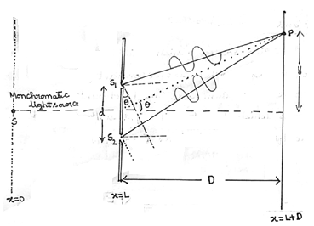**Approximation 2:** **d/λ >> 1:**Often, d is a fraction of a millimetre and λ is a fraction of a micrometre for visible light.

Δ=dsinΘ

Since, sinΘ is small.

So, sinΘ ≈ tanΘ. (Θ is small)

Δ=d tanΘ= λd/D

Δ=(SS₂+S ₂ P)-(SS₁ +S ₁P)

But, SS₂= SS₁

Δ= S₂P- S₁P=λd/D

https://cdn1.byjus.com/wp-content/uploads/2019/03/word-image201.png

For Constructive Interference:

Δ=nλ ; n ∈ I

Y n =nλD/d ; n ∈ I

Position of the bright fringes:

0, λD/d, 2λD/d , 3λD/d,…………nλD/d

For Destructive Interference:

Δ=(2n-1)λ/2 ; n ∈ N

(2n-1)λ/2 = yd/D

Y n =(2n-1)λD/2d ; n ∈ N

Position of dark fringes:

λD/2d , 3λD/2d, 5λD/2d,… …… (2n-1)λD/2d

Fringe Width:

**Fringe width** is the distance between two successive bright **fringes** or two successive dark **fringes**. In the interference pattern, the **fringe width** is constant for all the **fringes**..

β = Yn-Y n-1

β = nλD/d- (n-1)λD/d

β = λD/d